Binary Search Tree Balance Algorithm

This algorithm uses additional storage to hold the elements in tree.

Step 1: Use a LMR traversal to copy each element into an array of N elements.

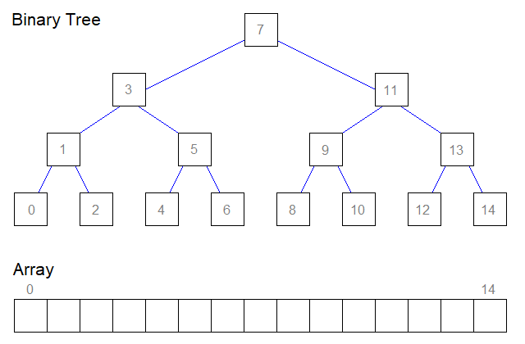

Step 2: Insert the middle element of the array into the tree. Recurse this step for the lower half of the array, then again for the upper half of the array.

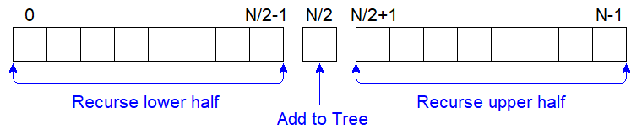

* *If N>0*
* *Insert map[N/2] into the tree*
* *Call Insert and pass lower half of map with a length of N/2*
* *Call Insert and pass upper half of map with a length of N-N/2-1*